Algorithm: Pseudocode of the proposed method
- Load the data D
- For image i to N in D do
- Resize to 128x128 pixels
- Normalize in range [0,1]
- Data Augmentation by random rotations, flips, and zooms.
- Get pre-processed dataset D’
- End for
- Split D’ into training T, validation V, and testing T’datasets
- For image in T do
- Initialize:
- Input_Image ← load input image
- Fixed_Layers ← pre-trained base layers (frozen, non-trainable)
- Trainable_Layers ← [
- Dense_Layer_1: 1024 neurons, activation=ReLU,
- Dense_Layer_2: 1024 neurons, activation=ReLU,
- Dense_Layer_3: 512 neurons, activation=ReLU,
- Dense_Layer_4: 15 neurons, activation=Softmax
- ]
- Pooling_Layer ← AveragePooling
- Optimizer ← Stochastic Gradient Descent (SGD)
- Loss_Function ← Categorical Cross entropy
- Batch_Size ← 15
- Epochs ← 40
- Model_Forward_Pass(Input_Image):
- features ← Fixed_Layers(Input_Image)
- pooled_features ← Pooling_Layer(features)
- output ← pooled_features
- for each layer in Trainable_Layers:
- output ← layer(output)
- return output
- Train_Model():
- for epoch in range(1, Epochs + 1):
- for batch in get_batches(training_data T, Batch_Size 15):
- images, labels ← batch
- predictions ← Model_Forward_Pass(images)
- loss ← Loss_Function(predictions, labels)
- gradients ← compute_gradients(loss, Trainable_Layers)
- update_weights(Trainable_Layers, gradients, Optimizer)
- Print ("Epoch", epoch, "completed.")
- Evaluate_Model(test_data T’):
- predictions ← Model_Forward_Pass(test_data T’)
- calculate_accuracy(predictions, 15)

Hard Voting
Input:
models ← [Xception, MobileNetV2, ResNet50, ResNet50V2, InceptionV3] // All trained for the same classes
input_image ← a preprocessed leaf image
Process:
predictions ← empty list
for each model in models:
predicted_class ← argmax(model.predict(input_image)) // get class with highest softmax score
append predicted_class to predictions

final_prediction ← mode(predictions) // most frequent class in the list
Output:
return final_prediction

Soft Voting
Input:
models ← [Xception, MobileNetV2, ResNet50, ResNet50V2, InceptionV3] // All pre-trained or fine-tuned
input_image ← a preprocessed image from the leaf disease dataset
Process:
Initialize total_confidence ← dictionary with all classes set to 0
for each model in models:
confidence_scores ← model.predict_proba(input_image) //
for i from 0 to number_of_classes - 1:
total_confidence[i] += confidence_scores[i] // Sum confidence for each class
final_prediction ← class index with max(total_confidence)
Output:
return final_prediction

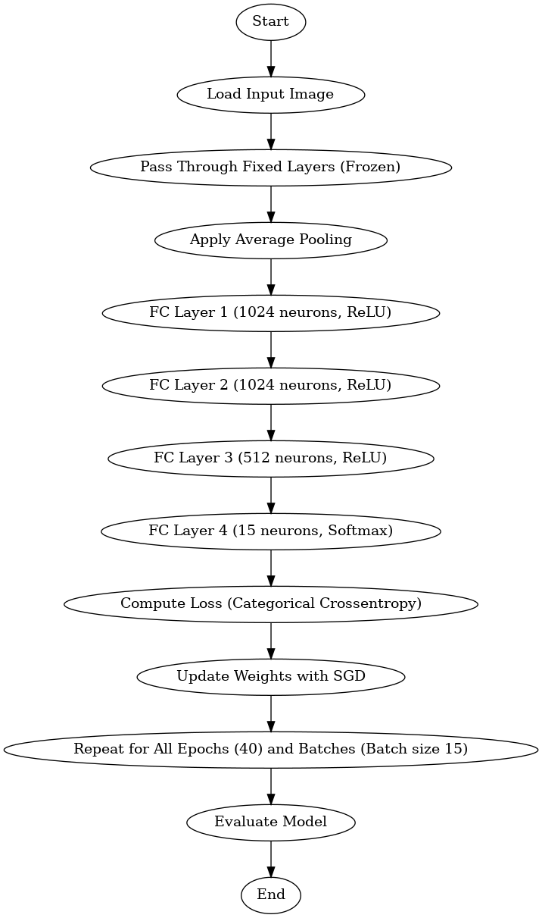

Flow Chart of Ensemble Learning Model

